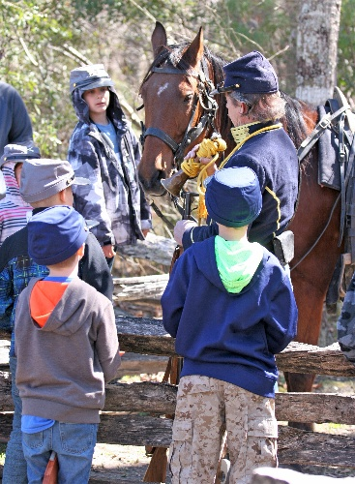


Saturday, April 11th
1:00 – 4:00 pm
New Bern Battlefield Park
300 Battlefield Trail

- Open to all children and adults. Arrive at 12:30 for registration.
- Cost $5 per person. No unaccompanied children. Reservations must be prepaid so we can prepare materials.
- Children 6-12 will be “recruited” by the Civil War reenactors, be issued a cap and wooden rifle to keep, and elect to either drill with reenactors or do crafts and historic games. The children will also visit various Civil War-era displays.
- Other visitors (adults, teens, younger children) are free to visit the Civil War-era displays:
- Civil War-era medical displays
- Military camp life display & storytelling vignettes
- Historic equipment & tool displays
- Pine pitch & tar demo; make your own “True Tar Heel” certificate
- Cavalry horse display & bugler
- Cannon firing demonstrations
- Library TechMobile with free wifi and historical resources for children and adults
- Telegraph display by New Bern Amateur Radio Club

- The event culminates with the children in an exciting mock battle followed by homemade apple crisp.
- This is a “rain or shine” event which will only be cancelled in the event of thunderstorms or high winds.

For reservations visit www.newbernhistorical.org
or call the New Bern Historical Society at 252-638-8558.

new bern historical society

